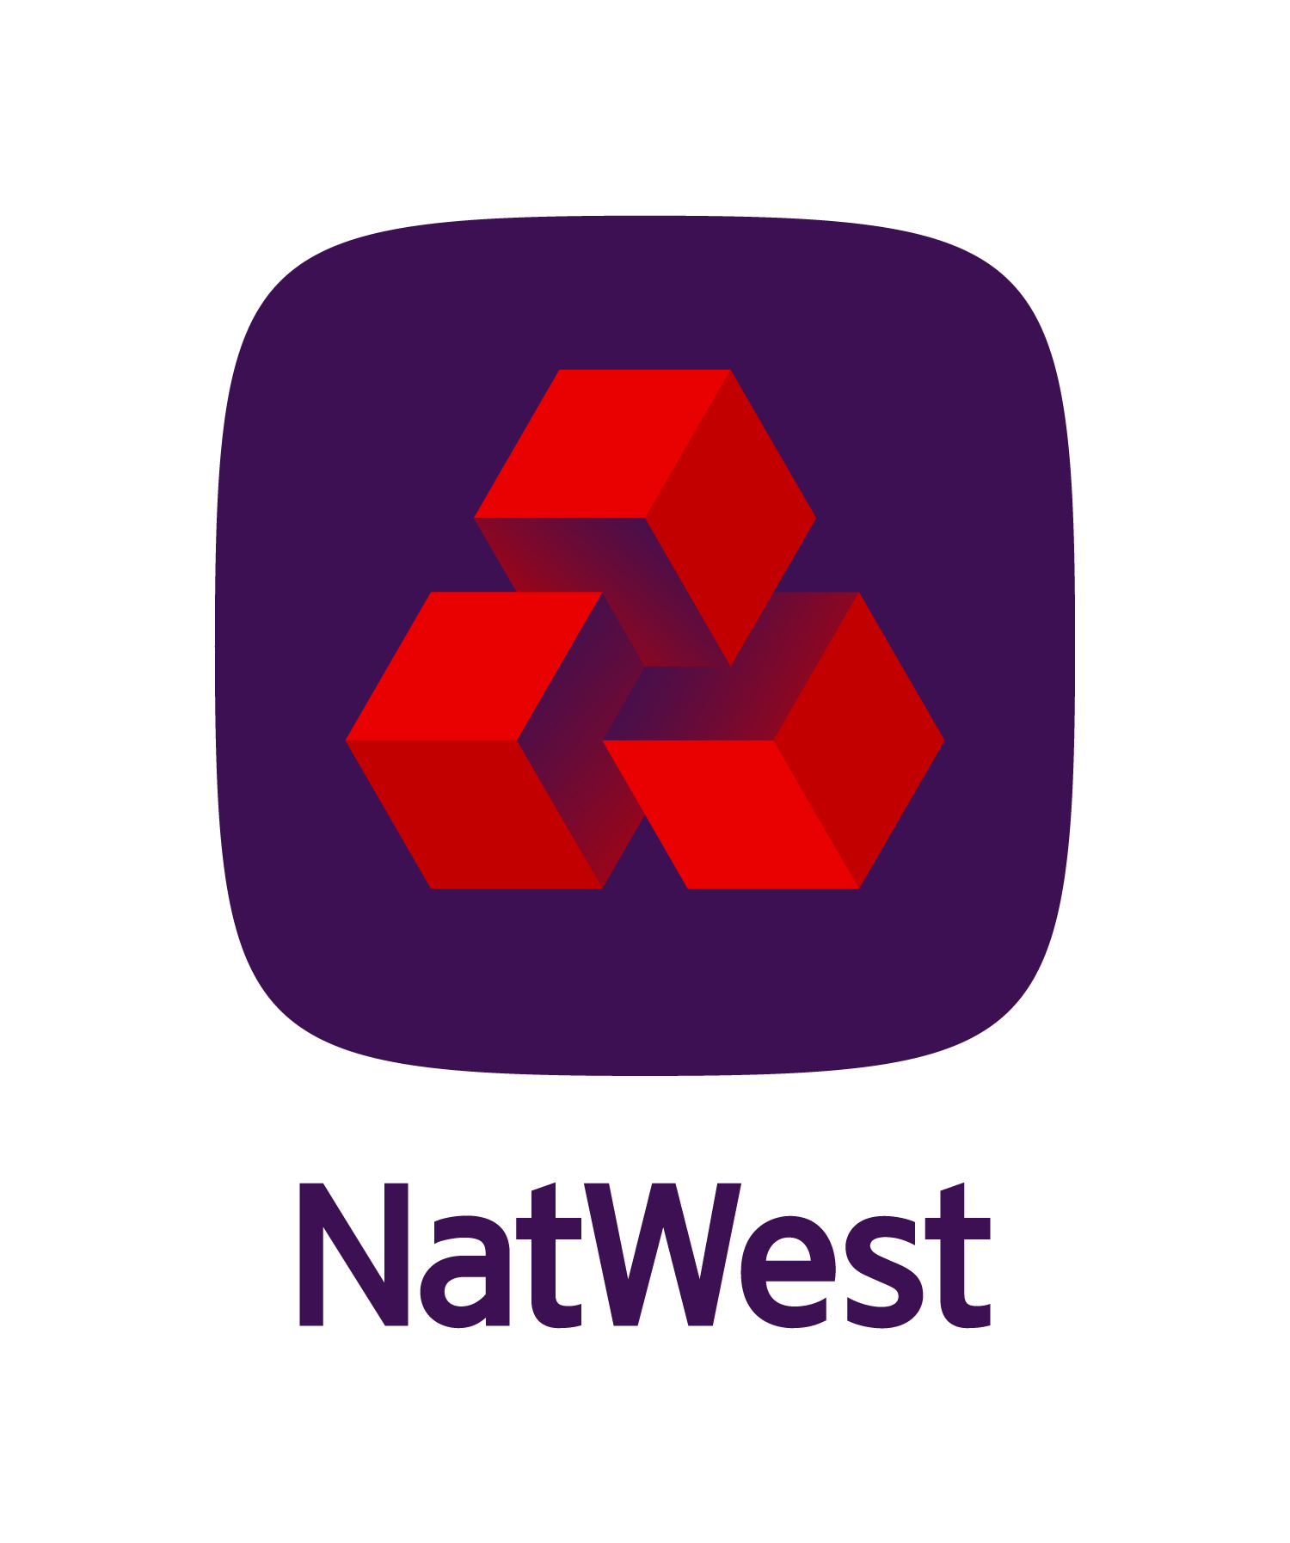

Day Care Nursery

Business plan template

# Instructions

1. Thank you for downloading this business plan template. Please feel free to delete this page after you have read the instructions below.
2. Refer to the Day Care Nursery Business Management Toolkit for help on completing this plan.
3. Where needed, sections have summaries that briefly explain how to fill out each box. Detailed guidance on completing the various sections of this business plan template can be found in the toolkit.
4. The structure of this document is a guide only – you may wish to delete (or add) sections to this plan depending on your business needs or the intended audience.

# About the business

**Trading name** [Enter the name of your business]

**Structure** Company, Partnership, Sole proprietorship [delete where appropriate]

**Established** [Enter date]

### Locations, outlets, countries

[Note down your office and branch locations, if applicable.]

## Contact details

[Enter your name]

[Enter your main phone number]

[Enter your mobile phone number]

[Enter your email address]

[Enter your postal address]

[Enter your physical address]

# 1. Business overview

## What we do

[Write a summary of the main day care services your business offers and how you do it. (Age of children, leased premises or your own building, in someone else’s facility, in people homes, etc]

## Location

[Describe your location and surroundings (such as rural, suburban, city, close to businesses, etc) and facilities (such as parking, bus services, type and size of premises.]

## The future

[Outline a brief vision of your goals and where you see your business going and the opportunities ahead, for example new locations, partnerships, expand geographically, more funding to increase capacity, etc.]

# 2. Business background

## History

[Write down the history of the business and major achievements. If you are just starting up, outline your sweat equity: what you’ve achieved so far.]

## Services

[Expand in more detail the services your business offers, and any specific attributes that give you a competitive advantage.]

## Intellectual property

[List the IP you have protected (such as unique teaching methods), or if you’re starting up, outline what you need to protect.]

## Intellectual assets

[List your intellectual assets: those things that you can’t legally protect, but are invaluable, such as knowledge of the day care industry, processes, parent relationships. Outline how you’ll protect them.]

# 3. Competitive advantage

## Our competitive advantage

[Competitive advantage is what you do better than your closest rival, and that matters to a parent assessing your business. Describe in one or two sentences things that you’re proud of that you think make your business special. If you’re starting up, outline what you’ve personally achieved.]

### Credentials

[List all the memberships, qualifications, and certifications your business has.]

### Training programmes

[List all the ongoing training you provide for your staff.]

### Partnerships

[List any other organisations you have partnerships such as local schools, businesses or community groups and describe the nature of the relationship.]

### Defending our competitive advantage

[Describe how you have been able to lock in any aspects of your competitive advantages. (Such as legal protection of your trading name or regional agreements.]

## Location

### Protecting our location

[Outline how you can ensure your business can retain a competitive location. (Lease agreements, able to move when demographics change, room to expand, etc, then use the list below to record any issues that need to be solved.]

|  |  |
| --- | --- |
| Issue | Action to take |
| **[eg Could be asked to leave premises]** | [eg Re-negotiate your lease term for a lengthier period plus a right of renewal or buy premises instead of leasing.] |
|  |  |
|  |  |
|  |  |
|  |  |
|  |  |

### Location efficiency

[If your needs change, how could you alter your current facilities to expand, or repurpose?]

## Parent relationships

### Parent-teacher partnership contract

[Describe your process when onboarding new children and parents. Do parents understand what to expect and how to work with you? Is there a partnership contract? Outline briefly the conditions and expectations in the contract.]

### The parent journey

[List the activities below you think parents go through before making the decision to use your day care nursery and use the table below to list the actions you can take to ensure you are chosen over the competition.]

|  |  |
| --- | --- |
| Activity | Action to take |
| **[eg Visiting your premises]** | [eg Create a checklist of answers to typical questions to help prepare. Offer handbooks or professionally designed marketing materials] |
|  |  |
|  |  |
|  |  |
|  |  |
|  |  |

## Compliance

### Professional assistance

[Briefly describe how you use professional advice then list the professional services you are using to help you in your business in the table below.]

|  |  |
| --- | --- |
| Name | Services used |
| **[eg Professional Association for Childcare and Early years]** | [eg Staff training and business insurance] |
|  |  |
|  |  |
|  |  |
|  |  |
|  |  |

### Ofsted reviews

[Outline any previous reviews you have had and what issues (if any) were raised, then compete the table below, listing improvements you could make in each of the key areas covered by a review. Add extra rows to add more categories.]

|  |  |
| --- | --- |
| Review category | Actions to take |
| Monitoring and evaluation |  |
| Planning for challenge |  |
| Suitable people |  |
| Management of staff |  |
| Safeguarding and managing risk |  |
| Working with parents |  |

## Competitors

### Competitor analysis strategy

[List your competitors below and summarise here how you will combat your competitors’ strengths and target their weaknesses.]

|  |  |  |
| --- | --- | --- |
| Competitor | Strengths | Weaknesses |
|  |  |  |
|  |  |  |
|  |  |  |
|  |  |  |
|  |  |  |
|  |  |  |

## Promoting our competitive advantage

[Outline the ways that you make your clients and other parents in your area aware of your uniqueness and all the above aspects of your business.]

# 4. SWOT

|  |  |
| --- | --- |
| Strengths | Weaknesses |
| Outline your strengths  [eg Amazing qualified staff] | Outline your weaknesses |
| Outline how you will protect your strengths  [eg Create a bonus system for high-performing staff.] | Outline how you will reduce your weaknesses |

|  |  |
| --- | --- |
| Opportunities | Threats |
| Outline your opportunities | Outline your threats |
| Outline how you will maximize your opportunities | Outline how you will reduce the impact of the threats |

# 5. Funding and finance

[Not all the financial information will be relevant; choose the sections that apply.]

## Start-up costs

[Summarize the start-up costs of your business.]

## Funding

[If you need future funding, detail in the table below, what it’s for and where you will get it from such as cash flow, lending, equity.]

|  |  |
| --- | --- |
| Funding purpose | Source of funding |
| [eg Cash shortfall] | [eg Personal savings] |
| [eg Developing new product] | [eg Apply for a grant] |
| [eg Open more locations] | [eg Equity funding, approach Angel Investor] |
|  |  |
|  |  |
|  |  |

## Cash flow forecast

[Attach a forecast for the next year to your business plan and note here any explanations, summary required.]

## Balance sheet forecast

[Attach a forecast for the next year to your business plan and note here any explanations, summary required.]

# 6. Profitability

## Profit and Loss Forecast

[If you use accounting software, either transfer the results to the table below, or attach a complete Profit and Loss download.]

|  |  |  |  |
| --- | --- | --- | --- |
|  | Last year | This year | Next year |
| Sales | $[Enter] | $[Enter] | $[Enter] |
| Costs | $[Enter] | $[Enter] | $[Enter] |
| Profit/loss | $[Enter] | $[Enter] | $[Enter] |

## Tactics to improve profit

|  |  |
| --- | --- |
| Increase leads | Notes |
| [eg Run webinars] | [eg Team up with local primary school and promote to their parents] |
|  |  |
|  |  |
|  |  |
|  |  |
|  |  |

|  |  |
| --- | --- |
| Improve conversion rate | Notes |
| [eg Identify the main objections and fix] | [eg Follow up people who enquire but don’t enrol.] |
|  |  |
|  |  |
|  |  |
|  |  |
|  |  |

|  |  |
| --- | --- |
| Increase what we sell | Notes |
| [eg Offer books that people can buy] | [eg Many of the books we use would be popular for parents to have at home.] |
|  |  |
|  |  |
|  |  |
|  |  |
|  |  |

|  |  |
| --- | --- |
| Increase average value | Notes |
| [eg Offer after hours care] | [eg Charge a higher hourly rate] |
|  |  |
|  |  |
|  |  |
|  |  |
|  |  |

|  |  |
| --- | --- |
| Increase prices | Notes |
| [eg Survey competitors.] | [eg Ensure we offer a better product if we are more expensive.] |
|  |  |
|  |  |
|  |  |
|  |  |
|  |  |

|  |  |
| --- | --- |
| Improve margin | Notes |
| [eg Research supplier options for electricity] | [eg Also check we are on the most efficient option.] |
|  |  |
|  |  |
|  |  |
|  |  |
|  |  |

|  |  |
| --- | --- |
| Improve productivity | Notes |
| [eg Streamline payment options] | [eg Instal contactless payment system.] |
|  |  |
|  |  |
|  |  |
|  |  |
|  |  |

## Other options

[Note down any other ways you can improve profitability.]

# 7. Marketing

## Market research

### Current research

[Describe any market research you are currently conducting and what you’ve learned from it.]

### Future research

[Using the table below, record what information you need answers to and how you’ll find it.]

|  |  |
| --- | --- |
| Direct research required | Method |
| [eg What we are not doing well] | [eg Parent questionnaire, ask when checking in children.] |
|  |  |
|  |  |
|  |  |
|  |  |
|  |  |

|  |  |
| --- | --- |
| Secondary research required | Method |
| [eg How big our market is] | [eg Look up census data on the Office for National Statistics.] |
|  |  |
|  |  |
|  |  |
|  |  |
|  |  |

## Marketing plan

### Target market

[Describe your target market in detail. Who are your best parents to work with and what characteristics do they have? The more detail you add here, the easier it will be for you to develop targeted tactics to promote to them. Then list the different targets in summary in the table below.]

|  |  |
| --- | --- |
| Target customer | Description |
| [eg Parents who work for the local council] | [eg Our premises are close to the council offices so it’s easy for parents to drop off and pick up children.] |
|  |  |
|  |  |
|  |  |
|  |  |
|  |  |

## Promotions

[Describe here the promotional methods you are using, then record the tactics in the table. Make sure you have an adequate budget in your cash flow forecast for your tactics.]

|  |  |  |  |
| --- | --- | --- | --- |
| Tactic | Message | Performance | Cost |
| [eg Fliers at local council office] | [eg ‘Your closest day care nursery’] | [eg About 1 inquiry per week.] | [eg £400] |
|  |  |  |  |
|  |  |  |  |
|  |  |  |  |
|  |  |  |  |
|  |  |  |  |

## Online marketing

### Current ranking

[Search for your business online and record the results here.]

|  |  |  |
| --- | --- | --- |
| Keyword or phrase | Page position | Action to take |
| [eg Day care in xyz town] | [eg #9] | [eg Rewrite content on the website to include references to ‘xyz town’] |
|  |  |  |
|  |  |  |
|  |  |  |
|  |  |  |
|  |  |  |

### Website content

[Read over your website and note any plans you have to improve the content to better describe your competitive advantages and appeal more to your target markets.]

### Website technical improvements

[Review your website on desktop, tablet and cell phone screens and note here any improvements required. Note: be sure to check that inquiry forms, etc., actually work on all devices.]

### Social presence and communications

[Note below any social media platforms or systems you use and why. If there are any gaps, then add some ideas on what information you need to communicate and the platforms you could use.]

|  |  |
| --- | --- |
| Purpose | Platform/s |
| Keeping parents informed | [eg Facebook, website, parent email newsletters] |
| Promoting the business |  |
| Enhancing personal profile |  |
| Keeping in touch with the industry |  |
|  |  |
|  |  |

# 8. Expansion

## Acquisition

[If you’re planning on acquiring another business, complete this section. Delete if not.]

[Describe your strategy and reasoning for purchasing another business. If you already have a business in mind, outline the opportunity and benefits, then use the table below to record any due diligence you’ve already done.]

|  |  |
| --- | --- |
| [Business name] | Notes |
| Location/lease remaining | [eg 22 Newbold Ave / 3 years] |
| Number of children enrolled/capacity | [eg 45/60] |
| Reputation |  |
| Ofsted report |  |
| Income/Gross profit/Net profit |  |
|  |  |
|  |  |
|  |  |

## New business models

[If you plan on changing your business model, complete this section. Delete if not.]

[Describe your ideas for a new business model. Outline the reason for changing and how it will benefit the business. Then summarise the steps you need to take to implement it.]

## Diversification

[If you’re planning on diversifying, complete this section. Delete if not.]

[Summarize your ideas for diversification then use the tables below to record each idea.]

|  |  |
| --- | --- |
| New Product/service | Notes |
| [eg Weekend cooking classes] | [eg About 10 students, once per month may generate an additional £500 per month] |
|  |  |
|  |  |
|  |  |
|  |  |

|  |  |
| --- | --- |
| Updated product/service | Notes |
| [eg Holiday programme] | [eg During school breaks offer themed activities based on season for older children.] |
|  |  |
|  |  |
|  |  |
|  |  |

## Partnerships

[If you’re planning on developing partnerships, complete this section. Delete if not.]

[Summarize your ideas for partnership/s, then use the tables below to record each idea.]

|  |  |
| --- | --- |
| Partner | Notes |
| [eg Local rugby club] | [eg club has access to parents from the area and will promote a discount deal to members] |
|  |  |
|  |  |
|  |  |
|  |  |

# 9. The team

## Management team

|  |  |  |
| --- | --- | --- |
| Position | Name | Qualifications |
| **[Position]** | [Enter name] | [Enter qualifications] |
|  |  |  |
|  |  |  |
|  |  |  |
|  |  |  |
|  |  |  |

## Childcare team

|  |  |  |
| --- | --- | --- |
| Name | Qualifications | Training required |
| **[Person’s name]** | [Enter qualifications] | [Enter training] |
|  |  |  |
|  |  |  |
|  |  |  |
|  |  |  |
|  |  |  |
|  |  |  |
|  |  |  |
|  |  |  |
|  |  |  |
|  |  |  |
|  |  |  |
|  |  |  |
|  |  |  |

### Recruitment policies

[Record how you keep key staff and gain skilled workers within budget.]

### Recruitment process

[Record how you prepare job descriptions, conduct advertising and conduct testing and interviews.]

### Training programmes

[Describe any onboarding and training processes and programmes you offer new and existing employees.]

### Retaining employees

[Explain any loyalty and incentives programmes and employee career paths. Describe your management's good practices and how you provide growth opportunities. List any tools you offer that help employees excel in their roles.

### Contingency plans for staff turnover

[Note how you plan to solve turnover rates. For example, you could create a talent pool or call in part-time/casual employees or volunteers. What partnership opportunities exist?]

### Social responsibility

[Outline the processes you have or intend to have in place to provide employees with work/life balance and to take care of their mental and physical health. What sustainability practices do you have, including any green and carbon neutral initiatives?]

### Issues

[Have you identified any issues relating to how you manage your staff? Record your thoughts on improvements here. This could include issues such as adequate work/life balance, conflicts, and underperformance.]

# 10. Other information you want to add

[Outline anything else you feel is important to add to your business plan.]